Abstract

With the advent of the Internet, online hotel reviews and ratings play a key role in a traveller’s decision-making process. With reviews in several websites, travellers have multiple options available to them at different price points. The purpose of this project is to identify and rank the best hotel based from dataset containing 1399 user reviews utilising the scientific methods of text mining to analyse and determine the ratings of the reviews. The reviews are passed through various stages including pre-processing, word frequency analysis, sentiment analysis and other approaches of Natural Language Processing and ranking of hotel is made based on reviews. Thus, text mining analysis can be utilised by hotels to improve the experiences offered to guests and have a better understanding as to which aspects of their services they need to focus on.

Keywords: Text Mining, Sentiment Analysis, Natural Language Processing, Term frequency – inverse document frequency(tf-idf)

TABLE OF CONTENT

Abstract 3

Table of Content 4

Introduction 5

Theoretical Background 6

Text mining. 6

Data Pre-processing 6

Tokenization 6

Stemming and Lemmatization 6

Elimination of Stop Words 6

Natural Language Processing 6

Sentiment Analysis 7

Tf-idf 7

Hypotheses 8

Methods 9

Research Design 9

Measures 11

Analysis 11

Results 12

Discussion and conclusion 16

Summary and Contribution 16

Implications for Research 16

Implications for Practice 16

Limitations and Future Research 16

References 18

Einverständniserklärung (Seminar) 20

INTRODUCTION

The rapid evolution of the Internet generates huge amounts of data from multiple sources including websites, social media and IoT devices, estimated by the International Data Corporation to be around 40 trillion gigabytes in 2020. The same report claims that 37% of this generated data contains information worthy of being analysed. Governments and organizations have not only become aware of importance in analysing generated data, but also to optimize on data collection and organisation.

The scope of this report highlights the steps conducted in text analysis and the role it plays in the tourism industry, focusing more on hotel reviews. Insights on hotel reviews can narrowed down to various aspects of hotel experience such as service, food, location, room facilities as well as pricing. Customer feedback and its analysis plays an important role in understanding how a hotel can improve its operations, enabling them to gather valuable information on how they can cater their customers better.

The provided dataset contains 1399 user reviews of American hotels, spanning across 9 columns which include the details of the hotel name, address, city, country and province. The other details included are the reviewer’s username, the date of the review, its title and finally the text of the review itself. The task requirements involved using text mining techniques to evaluate the differing opinions about the hotels contained in the dataset in order to identify the best hotel from and rate the reviews on a scale of 1 to 5.
Alan K., Shantanu S., Shreyansh S., Vinudeep R.: Analysis of Hotel Reviews Using Text Mining Methods | 6

THEORETICAL BACKGROUND

Text mining, also called text data mining (Hearst, 1997) or knowledge discovery from textual databases (Feldman et al., 1995), refers to the process of extracting interesting and non-trivial patterns or knowledge from unstructured text data. An alternative perspective is that it is an extension of data mining or knowledge discovery from (structured) databases (Fayyad et al., 1996; Simoudis, 1996).

Data Pre-processing

Datasets normally consist of large volumes of heterogeneous data collected from multiple sources. Pre-processing is performed to ensure consistent and accurate analysis ensuring that quality is unaffected whilst simultaneously reducing the complexity and processing time involved in the mining process. There are several steps involved in the pre-processing process, namely:

Tokenization: The process of breaking a text string up into words, phrases, symbols, or other meaningful elements called tokens.

Stemming and Lemmatization: This involves identifying the stem or root of a word and eliminating the suffixes thereby reducing the number of words while matching the stems accurately, eventually reducing time and memory requirements. Morphological word forms with similar semantic relations are grouped while words without the same meanings need to remain separated.

Elimination of Stop Words: Stop words are articles, prepositions, pronouns and related words that do not contribute to the meaning of a sentence. By eliminating these words, the dimensionality of term space can be reduced thereby ensuring that only relevant words will be considered for the process of analysis.

Natural Language Processing

Information retrieval aims making document corpuses more accessible through search engines or interfaces for browsing. In contrast to that, the engineering of natural language processing (NLP) deals with tasks of processing human language. NLP has its roots down in artificial intelligence (AI) research, but there are other scientific domains which have approached the same problems as well, for example: linguistics (“computational linguistics”), electrical engineering (“speech recognition”) and psychology (“computational psycholinguistics”) (Jurafsky and Martin, 1999). Major target in NLP

are (Jurafsky and Martin, 1999): speech recognition and synthesis, natural language understanding and machine translation.

Sentiment Analysis

Sentiment analysis uses the natural language processing (NLP), text analysis and computational techniques to simplify the extraction or classification of sentimental words from reviews which have sentimental characteristics. Analysis of these sentiments and opinions has spread across many fields such as Consumer information, Marketing, books, application, websites, and Social. Sentiment analysis becomes a hot area in decision-making. Hundreds of thousands of users depend on online sentiment reviews. The main goal of analyzing sentiment is to analyze the reviews and examine the scores of sentiments. This analysis is divided into many levels: document level, sentence level ,word/term level or aspect level The sequence processes are of sentiment analysis evaluation and detection of the sentiment polarity (Doaa Mohey El-Din MohamedHussein, 2018)

Tf-idf

The procedure called Term Frequency - Inverse Document Frequency was introduced in a 1972 paper by Karen Spärck Jones under the name “term specificity”. Instead of representing a term in document by its raw frequency (number of occurrences) or its relative frequency (term count divided by document length), each term is weighted by dividing the term frequency by the number of documents in the corpus containing the word. The overall effect of this weighting scheme is to avoid common problem when conducting text analysis: the most frequently used words in a document are often the most frequently used words in the all sets of documents. In contrast, terms with the highest tf-idf scores are the terms in a document that are distinctively frequent in a document, when that document is compared other documents.

HYPOTHESES

Hypothesis 1 – The tf-idf method is more effective and accurately identifies

emotion and sentiment compared to tf method

Hypothesis 2 – The net tf-idf score of reviews from the given dataset can be used to rank the best hotels based on review ratings.

Figure 1. Conceptual Model
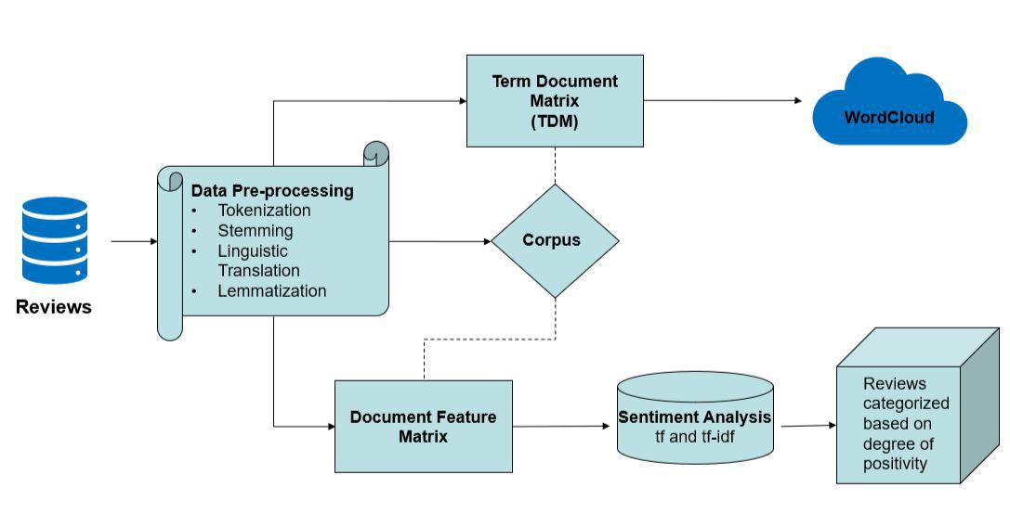

METHODS

Research Design

The research design was performed using the programming language R (Version 3.5.1) and RStudio (Version 1.1.463). Following the steps outlined in the conceptual model in Figure 1, the given dataset was analysed. It contains 1399 reviews in multiple languages (Figure 2), spanning across 9 columns which include the details of hotel name, address, city, country and province. The other details are reviewer’s username, date of the review, its title and finally the review text itself.

Using NLP techniques, the data is then pre-processed through tokenisation, stemming, lemmatisation and stop word removal to cleanse the data. Tokenisation involves breaking down text into words, phrases, symbols, or other meaningful elements called tokens by eliminating redundant spaces and helping to clean up data. Through stemming and lemmatization, similar words with different prefixes and suffixes were categorized into same segment which further streamlined out data for analysis. Using the tm package data was cleansed further and converted into a corpus. Stop words were eliminated from resulting in more meaningful content for analysis. Word frequency was also analyzed across the reviews and depicted using a word cloud (Figure 3), further simplifying sentiment analysis in the later stages. The word cloud is created using a Term Document Matrix (TDM), wherein the size of the word represented is directly proportional to the frequency of the word used in the reviews.

Figure 2 – Languages in the Dataset
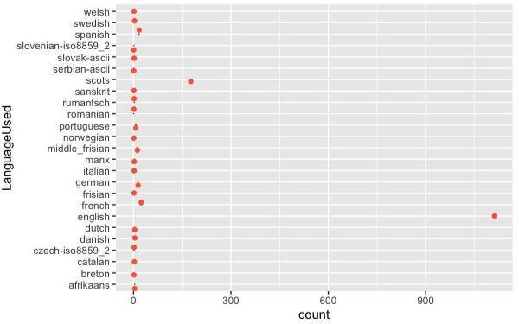

Figure 3 – Word cloud before and after pre-processing

Before Data Pre-processing After Data Pre-processing
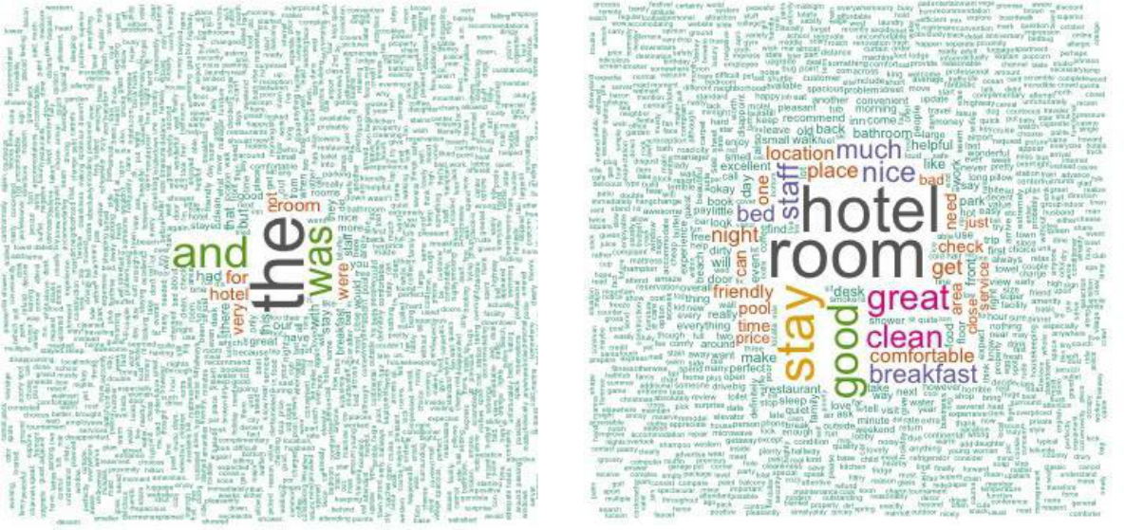

Figure 4 – Top 20 Words obtained using qdap package
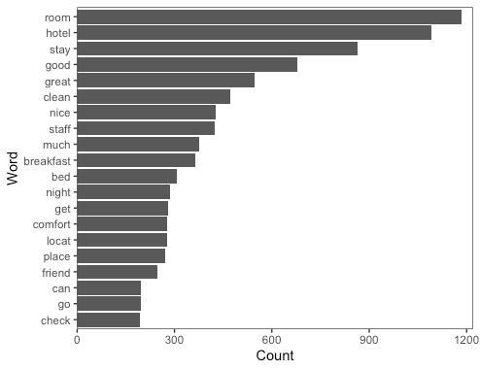

Measures

As part of analysis, the two columns ‘reviews.title’ and ‘reviews.text’ were considered. Both columns describe the title of the feedback and its detailed content as their names would suggest. Title and Feedbacks are given in different languages and some were written in different scripts all together, for pre-processing both rows are merged into a new column and on this column, all the pre-processing techniques are applied, and the output is directed to new column called ‘cleaned’.

Analysis

The columns review text and title are combined into a new column called ‘MergedTextColumn’ which is initially used for pre-processing. Non-English reviews are translated, and some languages such as Sanskrit were not considered as part of the analysis due to the lack of availability of translation packages for them. Data is then pre-processed using NLP techniques, such as tokenisation, stemming, lemmatisation and stop word removal.

Following this, sentiment analysis is performed by extracting the cleaned text into a corpus. A custom dictionary containing the positive and negative classification of words is loaded into the workspace and converted into positive and negative vector matrix. Next, a document feature matrix is created using corpus and dictionary (positive and negative matrix). A data frame is created by combining the cleaned text with the document feature matrix. Using term frequency techniques and comparing the positive and negative columns a label is assigned against each text to show if the cleaned text is a positive sentiment or a negative sentiment. A further analysis of the inverse document frequency technique tf-idf is performed next. For this, a tf-idf matrix is created using the dfm_tfidf function of the quanteda package which takes the document feature matrix as an input and schema as inverse. This resulted in assigning an inverse frequency number against each cleaned text in positive and negative category, against which a label was assigned.

The results of tf and tf-idf results were then compared and certain case-by-case analyses by observing the reviews themselves showcased that the latter proved to be a more accurate analysis of the given text. This conclusion was drawn on the basis that some selected reviews ended up being classified as positive as per the tf method, but were negative reviews based on the context, as the tf-idf method was able to accurately identify.

A table was then created to summarise the hotels and their associated ratings using their net tf-idf scores (combining positive and negative tf-idf scores) to obtain a weighted average, which showcased that “Anaheim Marriott Suites” was the best hotel while “Fiesta Inn and Suites” had the lowest ratings. The limitation over here is that some hotels have one review while other have several, which needs be to be factored in while ranking hotels and rating the reviews.

Using the data.table package, a range was categorised from 1 to 5 and mapped back to table to determine the review ratings. The most negative review was assigned 1 and the most positive review was rated as 5. The data frame is exported as csv for reference purposes and further visualisation is done on the table containing review ranking and hotel ranking.

RESULTS

Top hotels and rating

Sl no | Hotel name |  | Positive count |  | Rating
1 | Anaheim Marriott Suites |  | 13 |  | 5
2 | Best Western of Long Beach |  | 13 |  | 5
3 | Doubletree By Hilton West Palm Beach Airport |  | 12 |  | 5
4 | Drury Inn and Suites Columbus Convention Center |  | 11 |  | 5
5 | Wine Valley Lodge |  | 10 |  | 5
6 | Courtyard By Marriott Downtown Boise |  | 9 |  | 5
7 | Hampton Inn & Suites Fort Worth-west-i-30 |  | 8 |  | 5
8 | Hampton Inn Tucson-airport |  | 8 |  | 5
9 | Hyatt House Colorado Springs |  | 8 |  | 5
10 | Best Western Knoxville Suites |  | 7 |  | 5

Figure 5 – Rating against the Number of Hotels
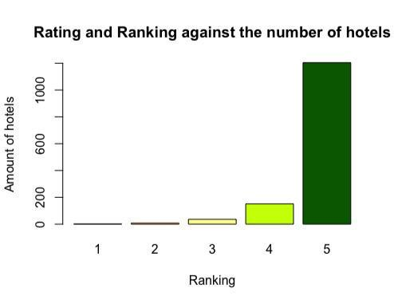

Figure 6 – Amount of Reviews per Province
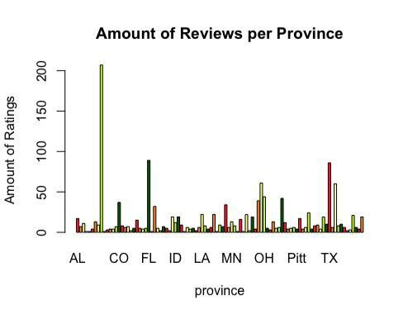

Figure 7 – Map of Number of Reviews versus Hotels
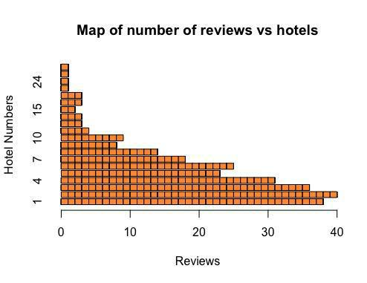

Figure 8 – Number of Reviews per Hotel
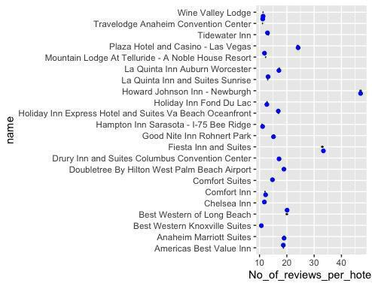

Figure 9 – Rating based on Weighted Average Review Sentiment
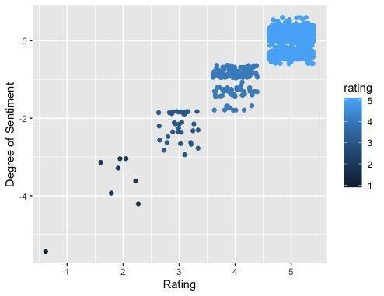

DISCUSSION AND CONCLUSION

Summary and Contribution

In today’s digital word, peer opinion plays a major role in influencing one’s perspectives. Reviews and rankings on travel websites are a great example of the contribution to a traveler’s decision-making process. We had this opportunity to analyze the customer reviews, sentiment and rank the hotel. We observed that customer sentiments vary from check-in till checkout. Text mining tools and techniques such as NLP, word frequency analysis, clustering and sentiment analysis helped us to analyze the reviews and to show the factors which plays pivotal role in deciding hotels based on ranking. The challenges of this project included language conversation to common language (English) and analyzing the sentiment through right technique (tf vs tf-idf).

Implications for Research

Our analysis will help in identifying the sentiment and rank the text and hotel accordingly, there are numerous instances in the real world where text mining can help companies or organizations to identify the sentiments and utilize the benefits of text mining to the fullest potential. Text mining is rapidly evolving field and we believe through our research and analysis on further research on optimization of techniques or development of new model for training, for example like language conversion or easy identification of sentiment based on this further algorithms and models can be researched and developed.

Implications for Practice

Our analysis can help practice to streamline the ranking and come up with better solutions for ranking of the hotels. Our research and analysis acts as basic guideline for analysing the user reviews and provide the ranking for hotels based on user sentiments. This can be leveraged by practice to further development of review analysis and text analysis.

Limitations and Future Research

The given dataset contained reviews in multiple languages, some of which (such as Sanskrit, Breton) could not be translated into English due to package limitations used (Google Translate and Microsoft Translate). The sentiment for these languages were

considered neutral and were not considered as part of the analysis. For future research, the best hotel could be determined categorically – in terms of service, amenities, food, location and other parameters. A custom dictionary could be formulated for each of these contexts to better analyze a hotel using these parameters. A score could be assigned for each of these categories, which could then be utilized to assess the rating of each review. In addition to this, weightage could be assigned to the number of reviews per hotel as part of their final score.

REFERENCES

Manning, C., Raghavan, P. and Schütze, H. (2018). Introduction to information retrieval. Cambridge: Cambridge University Press.

Beel, J., Gipp, B., Langer, S. and Breitinger, C. (2015). Research-paper recommender systems: a literature survey. International Journal on Digital Libraries, 17(4), pp.305-338.

M. H. Azhar, P. P. Adikara, and Y. A. Sari, “Analisis Sentimen pada Ulasan Hotel dengan Fitur Score Representation dan Identifikasi Aspek pada Ulasan Menggunakan K-Modes,” vol. 2, no. 9, pp. 2777–2782, 2018.

Laursen K, Salter A. 2006. Open for innovation: the role of openness in explaining innovation performance among U.K. manufacturing firms. Strategic Management Journal 27(2): 131–150.

Doaa Mohey El-Din MohamedHussein, “A survey on sentiment analysis challenges“ Volume 30, Issue 4, October 2018, Pages 330-338

Feldman, R. & Dagan, I. (1995) Knowledge discovery in textual databases (KDT). In proceedings of the First International Conference on Knowledge Discovery and Data Mining (KDD-95), Montreal, Canada, August 20-21, AAAI Press, 112-117.

Hearst, M. A. (1997) Text data mining: Issues, techniques, and the relationship to information access. Presentation notes for UW/MS workshop on data mining, July 1997.

Fayyad, U., Piatetsky-Shapiro, G. & Smyth, P. (1996). From data mining to knowledge discovery: An Overview. In Advances in Knowledge Discovery and Data Mining, U. Fayyad,

- Piatetsky-Shapiro, P. Smyth, and R. Uthurusamy, eds., MIT Press, Cambridge, Mass., 1-36.

Simoudis, E. (1996). Reality check for data mining. IEEE Expert, 11(5).

Bhimasankaram Pochiraju, Sridhar Seshadri (2019). Essentials of Business Analytics: An Introduction to the Methodology and its applications.

